32.5: a) 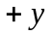 direction.
b) 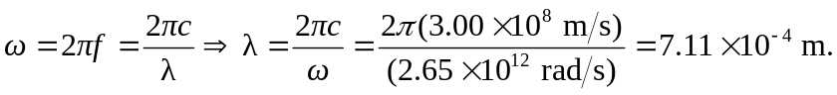
c) Since the electric field is in the -direction, and the wave is propagating in the -direction, then the magnetic field is in the -direction 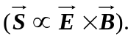So:
